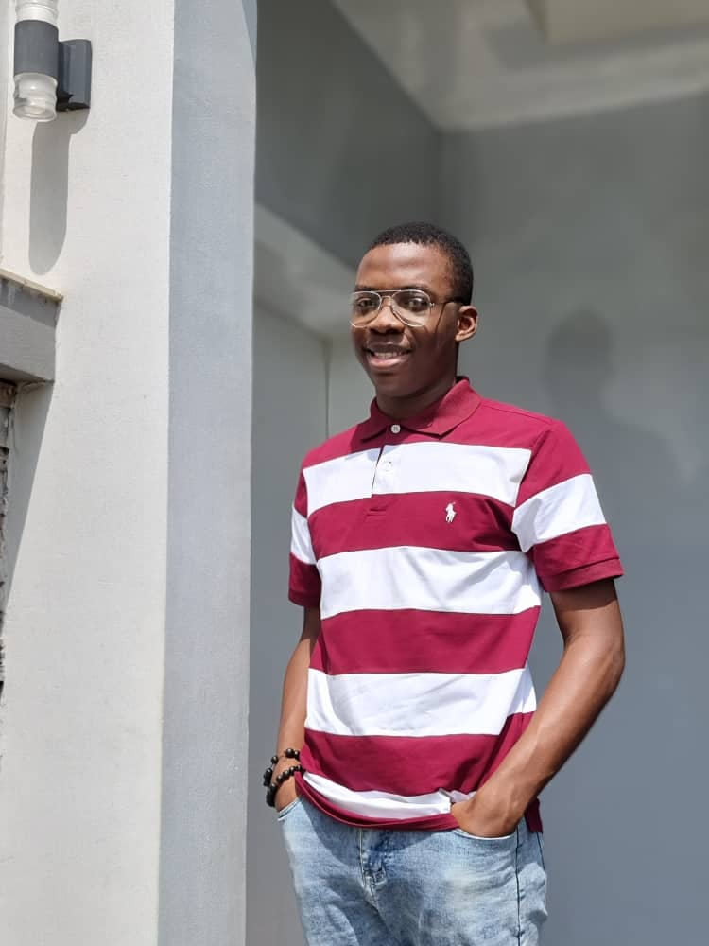

NOVEMBER 2022 – DECEMBER2022

PROJARO

TAUGHT SEVERAL STUDENTS VANILLA JAVASCRIPT AND REACT JS

EDUCATION

* SECONDARY SCHOOL LEAVING CERTIFICATE AT NIGERIA GHANA INTERNATIONAL COLLEGE (2014 – 2020)
* CERTIFICATE OF COMPLETION IN WEB DEVELOPMENT (MARCH 2020 – JUNE 2020)
* B.SC COMPUTER SCIENCE AT NIGERIA POLICE ACADEMY (0CTOBER 2021 – DATE)

NODE JS

NEXT JS

ADOBE AFTER EFFECTS

REDUX

CSS

linkedin.com/in/abubakar-musa-571867211

<https://github.com/seanboss-bit>

SKILLS

FOLLOW ME

AUGUST 2022 – OCTOBER 2022

INSTANT DEPOSIT LIMITED (INTERN)

ABUBAKAR MUSA SEAN

REACT

09056760660

SHAUNAIBEK@GMAIL.COM

KABUSA GARDENS ESTATE, ABUJA

EXPERIENCE

MAKING RESPONSIVE UI DESINGS, CONVERSION OF HTML, CSS AND JS CODE TO REACT, PRODUCTION OF SEVERAL API’S

W E B D ES I G N E R